**Valet Zone Application Checklist**

Per City Ordinance, Sec. 26-372(e), any establishment wishing to use the public streets for valet pick-up/drop-off of vehicles must do so in a valet zone that is designated by the City. To apply for a valet zone, please complete one application per requested valet zone. If you are requesting transfer of an existing valet zone, you must submit a completed application with all the information requested below. See Sec. 26-443.

**Please complete pages 3 - 4 and submit attachments A-D to ensure your application is processed timely:**

**ATTACHMENT A (page 4 of this application) – Submit with application**

Valet parking plan - include traffic flow plan and a map describing the vehicle routing on a sheet of paper at least 8.5 x 11” or 11 x 17” (see page 4 of this application). The diagram must include:

* On-street location of proposed valet zone
* All addresses, buildings, parking layouts, streets, street width, parking restrictions, parking meters, and fire hydrants within 150 feet of proposed valet parking operations
* Photo of proposed valet zone location pictured from the opposite side of the street
* Measure and detail on site plan the width of the street where the proposed valet zone will be located.
* Routes that vehicles will be driven to and from valet parking storage areas, number of attendants at zone

**ATTACHMENT B – Submit with application**

Description of vehicle storage location

* A copy of the contract or agreement allowing the storage of vehicles in an off-street facility
* The address for valet parking storage
* Number of spaces at off-street location for valet parking storage
* If vehicles are stored on-street outside the CBD, provide the following:
  + Block numbers and names of all streets where vehicles will be stored
  + Sides of the street that will be used for storage (N, S, E, or W)

**ATTACHMENT C – Submit with application**

Plan for safe and reasonable accommodations for persons with disabilities who wish to utilize the valet zone

**ATTACHMENT D – Submit with application**

Copy of Valet Parking Service permit held by valet parking operator

**PERMIT FEES (Fees are nonrefundable)** (cash, check, credit card or money order payable to the City of Houston)

**(Permit fees subject to sales tax of 8.25%; permit(s) over $50.00 are assessed a $33.10 Administration Fee)**

|  |  |  |  |  |
| --- | --- | --- | --- | --- |
| **Permit Type** | **Permit Fee** | **Sales Tax** | **Admin Fee** | **Total Fee** |
| Valet Zone – Annual (first time applicant) | $529.75 | $43.70 | $33.10 | $606.55 |
| Valet Zone – Annual Renewal | $397.31 | $32.78 | $33.10 | $463.19 |
| Valet Zone - Temporary | $264.88 | $21.85 | $33.10 | $319.83 |
| Valet Zone - Transfer | $99.93 | $8.24 | $33.10 | $141.27 |
| Valet Zone - Change | $13.24 | $1.09 |  | $14.33 |

The cost of postage to provide written notice to property owners and occupants within 200 feet of the proposed valet zone. Sec. 26-443(c). **Applies only to annual valet zone (first time applicant)**. You will be contacted for this payment once Parking Management has determined that the application is complete.

Signage fees of **$397.30** - **Applies only to annual valet zone (first time applicant).** (Actual cost of making and installing the required signage). You will be contacted for this payment if the application is approved.

**Valet Zone Provisions**

1. Proposed valet zones must allow two-way flow on two-way streets and maintain one lane open on one-way streets. Minimum street widths are:  
   1. Twenty-seven (27) feet on Two-Way streets with parking restricted on the opposite side of the proposed valet zone
   2. Twenty-two (22) feet on One-Way streets with parking restricted on the opposite side of the proposed valet zone
   3. Minimum valet zone width is nine (9) feet.
2. Valet operations shall not occur on Major Thoroughfares.
3. Applicant must demonstrate that the establishment has a need for the requested valet zone.
4. On-street parking shall not be reserved for valet operations and parking will be on a first-come first-served basis on the public right-of-way outside the Central Business District (CBD).
5. No valet zone within five (5) feet of a driveway. Requests for valet zones in front of a residential property will be reviewed on a case-by-case basis.
6. Minimum unobstructed pedestrian passage is not less than four (4) feet.
7. No interference to pedestrian or vehicular traffic will be permitted.
8. All posted parking restrictions shall be observed.
9. Access by emergency vehicles must be maintained at all times.
10. No cones may be used to reserve on-street parking spaces or block lanes within the proposed valet zone.

**The city traffic engineer may disapprove a** **valet** **parking plan on any of the following grounds:**

1. The valet parking plan does not contain or meet one (1) or more of the requirements of Article VII of Chapter 26 of The City of Houston Code of Ordinances.
2. The applicant has not submitted sufficient information or documentation for the city traffic engineer to determine whether the valet parking plan meets the requirements of this article.

***Failure to comply with the Valet Ordinance may result in the revocation of valet zone.***

**Valet Zone Application**

Check One:  Permanent Valet Zone - New  Change to existing zone (days, hours, and operator)

Permanent Valet Zone - Renewal  Temporary Valet Zone  Zone Transfer

|  |  |  |  |  |  |  |  |  |  |  |  |
| --- | --- | --- | --- | --- | --- | --- | --- | --- | --- | --- | --- |
| Applicant's Name: |  | | | | Phone number: | | | | | | |
| Applicant Address: |  | | City: | | State: | | | Zip: | |  | |
| Company’s Name: |  | | | | | | |  | | | |
| Company Address: |  | | City: |  | | State: | |  | Zip: | |  |
| Company Phone No: |  | Fax No: |  | | | Alt.No: | |  | | | |
| E-Mail Address: |  | | | | | | | | | | |
| Owner’s Name: |  | | | | Phone number: | | | | | | |
| Owner’s Address: |  | | City: | | | | State: | | Zip: | | |

**To list additional owners or additional commercial establishments served by this valet zone, please use a blank sheet of paper and attach to this page.**

|  |  |  |  |  |  |  |
| --- | --- | --- | --- | --- | --- | --- |
| Valet Zone Location (Block Number & Street) | |  | | | | |
| Keymap Page & Number: | |  | |  | | |
| Requested Days: | From: | |  | | To: |  | |
| Requested Hours of Use: | From: | |  | | To: |  | |

Each Day Continuous

Affected Side of the Street: (Circle One OR Explain Below) N S E W

|  |
| --- |
|  |

|  |  |
| --- | --- |
| Briefly explain reason for request (attach another sheet of paper if necessary): |  |

This application is to provide the Parking Management Division with information necessary to process your request. Additional information may be required. Submission of an application does not give the applicant any authority or permission to use or occupy any portion of the public street or right-of-way; an approved valet zone designation from the Parking Official is necessary before a valet operator may use a designated zone on the approved days and times. To ensure safe and efficient flow of traffic and pedestrians, the application may be modified, disapproved, and any previously-issued permits may be modified or revoked at the sole discretion of Parking Management in consultation with the Traffic Engineer’s Office. Permanent valet zones must be renewed annually.

Applicant Signature Date

|  |  |  |  |
| --- | --- | --- | --- |
| **FOR INTERNAL USE ONLY** |  |  |  |
| Number of Lanes Requested: |  | Number of Travel Lanes Currently Open: |  |
| Total Number of Parking Lanes: |  |  |  |

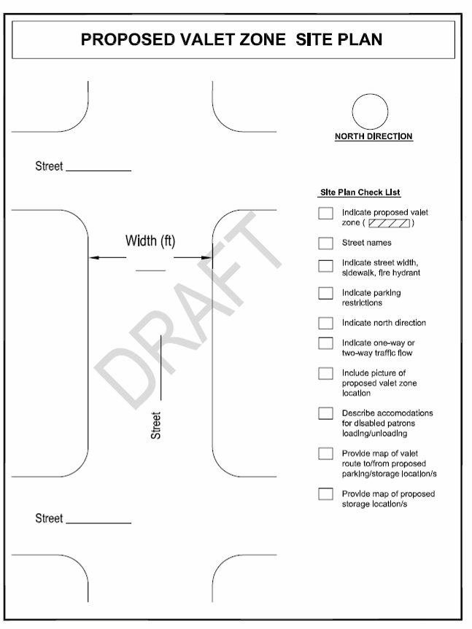

**Bus Routes on street**

**Attachment A**